Find Kozney\'s death quest (Hol IV) 6 Months, 2 Weeks ago | Karma: 54
This is a guide for the \'Find Kozneys death\' quest in HOL4. You get the quest from Tzar Yaromir in the royal sector. The Royal sector is located in Seversk Centre down some stairs. He asks you to find the four parts of Kozney’s death and either destroy them or bring them to him.
Locations
Location of the rabbit
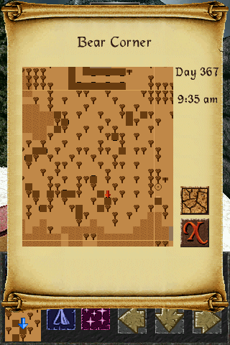
Location of the needle (red tree)
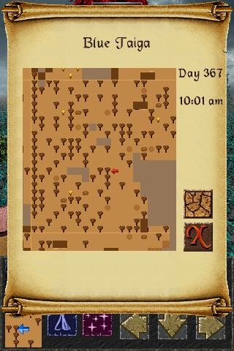
Breakable wall in Crystal Goosed Village- Just give it a whack
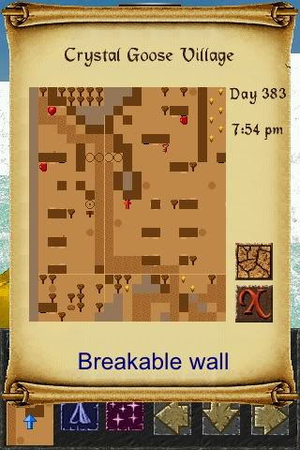
Location of the duck
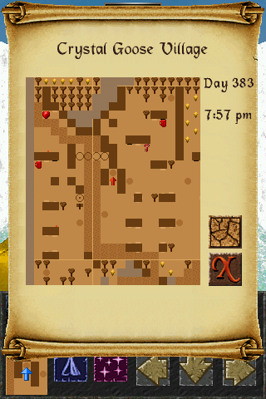
For all of the above simply tap the object in front of you
The last part of kozneys death is the oak tree in the first floor of his dungeon. To destroy it use the burning hand spell.
Oak Tree
